**MAT2001 – Statistics for Engineers - ELA (R Code Studio), Winter Semester 2020-2021**

**Lab Assessment - IV**

**By: Jonathan Rufus Samuel (20BCT0332) Date: 17.6.2021**

__________________________________________________________________________________

**Write R code to solve the following problems:**

**Q1) A particular brand of tires claims that its deluxe tire averages at least 50,000 miles before it needs to be replaced. From past studies of this tire, the standard deviation is known to be 8000. A survey of owners of that tire design is conducted. From the 28 tires surveyed, the average lifespan was 46, 500 miles with a standard deviation of 9800 miles. Do the data support the claim at the 5% level?**

A: Code is as follows:

#Q4.1

#Let H0: x0 = mu (Average lifespan of sample and population of tires ARE EQUAL)

#Let H1: x0 != mu (Average lifespan of sample and population of tires ARE NOT EQUAL)

#i.e. 2 tailed Test

#Proceedings for Z-Test for Single Mean

alpha = 0.05

ztab = qnorm(1-alpha/2)

ztab

mu = 50000

sigma = 8000

n = 28

x0 = 46500

zcal = (x0 - mu)/(sigma/sqrt(n))

zcal

abs(zcal)

#As |Z|>Zalpha, therefore H0 is rejected and H1 is accepted.

#i.e. The claim cannot be supported at 5% level

**Output (via Command Window):**

> #Q4.1

>

> #Let H0: x0 = mu (Average lifespan of sample and population of tires ARE EQUAL)

> #Let H1: x0 != mu (Average lifespan of sample and population of tires ARE NOT EQUAL)

> #i.e. 2 tailed Test

>

> #Proceedings for Z-Test for Single Mean

> alpha = 0.05

> ztab = qnorm(1-alpha/2)

> ztab

[1] 1.959964

> mu = 50000

> sigma = 8000

> n = 28

> x0 = 46500

> zcal = (x0 - mu)/(sigma/sqrt(n))

> zcal

[1] -2.315032

> abs(zcal)

[1] 2.315032

> #As |Z|>Zalpha, therefore H0 is rejected and H1 is accepted.

> #i.e. The claim cannot be supported at 5% level

**Result**: As |Z|>Zalpha, therefore H0 is rejected and H1 is accepted. i.e. The claim cannot be supported at 5% level.

**Implementation on R Studio Code (via Command Window):**

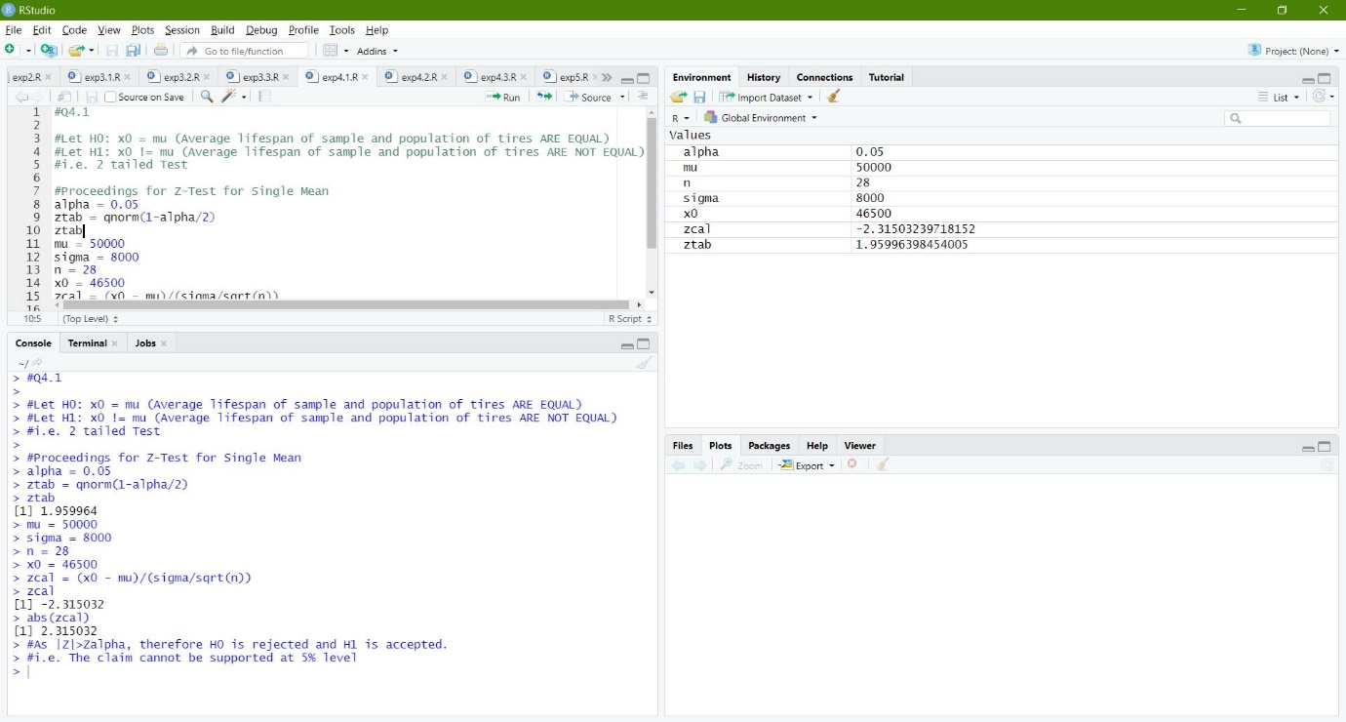

**Q2) In the large city A, 20 per cent of random sample of 900 school children had defective eye-sight. In the large city B, 15 percent of random sample of 1600 school children had the same defective. Is this difference between the two proportions significant? Obtain 95% confidence limits of the difference in the population proportions.**

A: Code is as follows:

#Q4.2

x<-c(180,240)

n<-c(900,1600)

prop.test(x,n,correct=FALSE)

**Output (via Command Window):**

> #Q4.2

> x<-c(180,240)

> n<-c(900,1600)

> prop.test(x,n,correct=FALSE)

2-sample test for equality of proportions without continuity correction

data: x out of n

X-squared = 10.302, df = 1, p-value = 0.001329

alternative hypothesis: two.sided

95 percent confidence interval:

0.01855096 0.08144904

sample estimates:

prop 1 prop 2

0.20 0.15

**Result**: Here there is significance as the P value is less than 0.05 The confidence limits are 1.855% to 8.14%.

**Implementation on R Studio Code (via Command Window):**

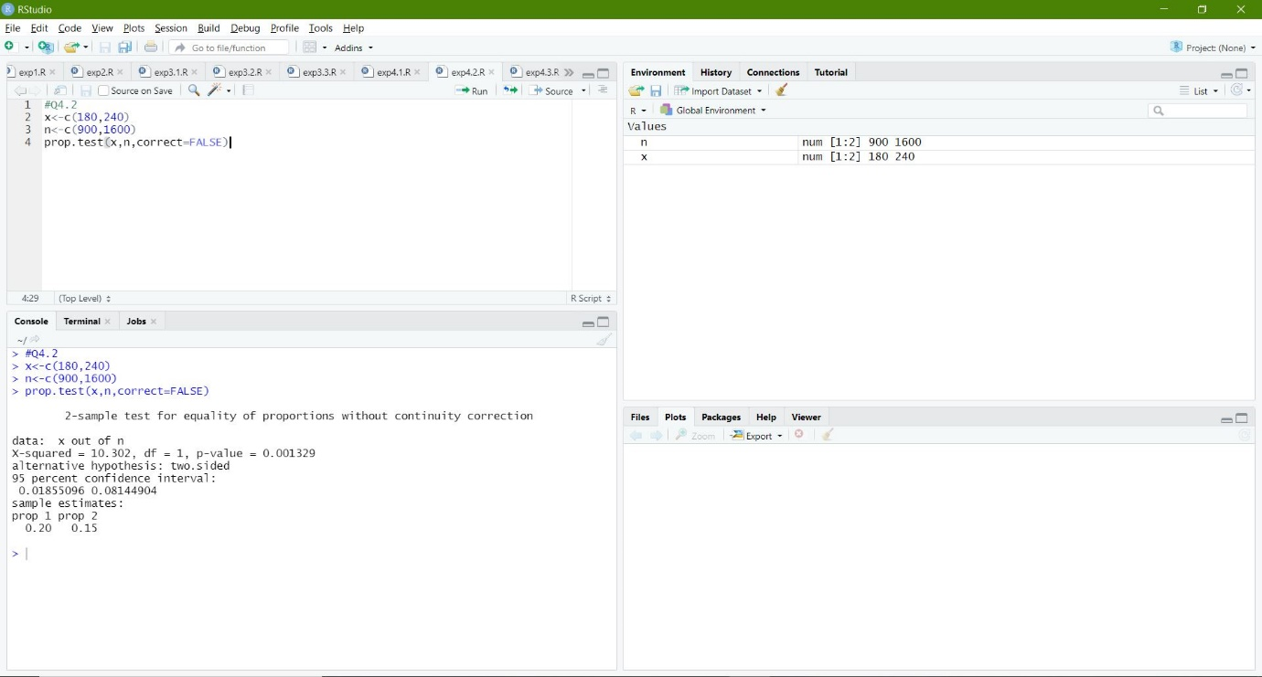

**Q3) A cigarette manufacturing firm claims its brand A of the cigarettes outsells its brand B by 8%. if it’s found that 42 out sample of 200 smoker prefer brand A and 18 out of another random sample of 100 smokers prefers brand B, test whether the 8% difference is a valid claim.**

A: Code is as follows:

#Q4.3

x<-c(42,18)

n<-c(200,100)

prop.test(x,n,alternative="greater",correct=FALSE)

**Output (via Command Window):**

> #Q4.3

> x<-c(42,18)

> n<-c(200,100)

> prop.test(x,n,alternative="greater",correct=FALSE)

2-sample test for equality of proportions without continuity correction

data: x out of n

X-squared = 0.375, df = 1, p-value = 0.2701

alternative hypothesis: greater

95 percent confidence interval:

-0.04897867 1.00000000

sample estimates:

prop 1 prop 2

0.21 0.18

**Result**: Here the P value is greater than alpha L.O.S value. Hence accept the null hypothesis.

**Implementation on R Studio Code (via Command Window):**



